
Lesson 13: A Hit That Reacts
001 Game Creator (Windows only)
VIDEO GAME CREATION
This week: getting hit finally LOOKS like getting hit. A brief flash, then a small explosion, before the enemy disappears.
Open your own [YourName]Game project from Lesson 12 - don't start a new one.
Important: your score, lives, wave, and win/lose logic should all still work exactly as before. Today only changes how the enemy's removal LOOKS, not when your game-state actually changes.

Setup
- Open your [YourName]Game project from Lesson 12.
- Create a new Actor Template named Explosion, using explosion_placeholder.png as its Graphics.

Level 1 - Minimal (MVP)
On every hit, the enemy briefly flashes, and a small independent explosion effect appears and cleans itself up. Score, lives, wave, and win/lose logic are all unaffected.
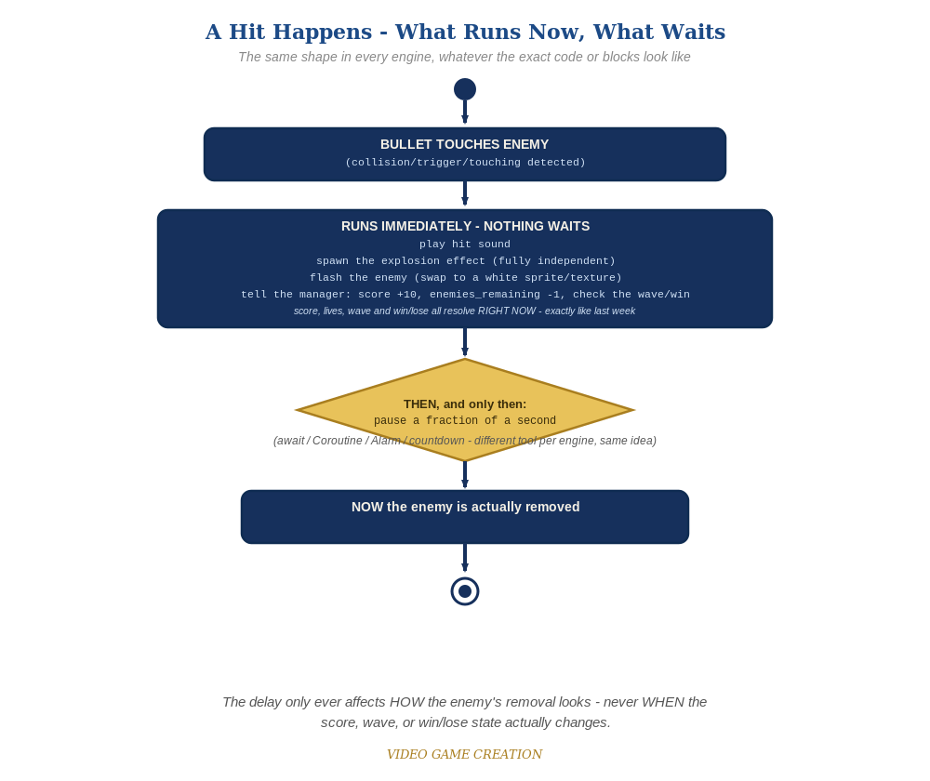
Everything in the top box happens the instant the hit is detected. Only the enemy's own removal - the very last step - waits for the pause to finish.
- On the enemy Actor's "Collided with actor" Trigger, right after the existing sound/score/win-check actions, add Actor – Flash (a real, built-in action that flashes a color on the Actor for a set duration - set a short duration, e.g. 0.2 seconds).
- In the same action list, add Spawn Actor(Explosion) at the enemy's current position - this happens immediately and is fully independent of everything else.
- Leave the enemy's existing Actor – Destroy/Revive(Destroy) action exactly where it already is, unchanged - in this engine, the flash and the destroy happen close together rather than with a manual delay between them (see the note below).
- If your version supports a Lifetime/Duration property when spawning an Actor, set the Explosion's to a short value (e.g. 0.3 seconds) so it removes itself automatically.
- Save, then Play/Test and play through a full round - each hit should show a small burst at that spot; the enemy's own flash may or may not be fully visible depending on your version (see note below).
enemy Actor Trigger: Collided with actor (revised) ->
If(game_active = 1)
Variable – Modify Value(score, Add, 10)
Variable – Modify Value(enemies_remaining, Subtract, 1)
Play Sound(sfx_hit.wav)
Actor – Flash(White, Duration: 0.2)
Spawn Actor(Explosion) at (this actor's position)
If(enemies_remaining <= 0)
If(wave >= total_waves)
Variable – Modify Value(game_active, Set, 0)
Play Sound(sfx_win.wav)
Message Box("You Win! - Press R to Restart")
Else
Variable – Modify Value(wave, Add, 1)
Variable – Modify Value(enemies_remaining, Set, 5)
Play Sound(sfx_wave.wav)
Call Custom Event(SpawnWave)
Actor – Destroy/Revive(Destroy)

Level 2 - Complete (Alpha/Beta)
The flash and explosion play correctly on every single hit, with no leftover explosions, no enemies stuck mid-flash, and no change to score/lives/wave timing.
- Play a full round: an explosion appears at every hit and cleans itself up; score, lives, wave, and win/lose all still happen at exactly the moments they did last week.
- Confirm Explosion Actors never pile up on screen across a long playthrough.
- This engine's flash may complete quickly or be cut short depending on your version - Level 2 here means the explosion effect is consistently visible, even if the enemy's own flash is brief.

Level 3 - Refined (Ready to Publish) - pick any that interest you
- Audio/Visual: if your version supports it, explore a Timer or delay mechanism to hold the enemy's Destroy action for a fraction of a second after Flash starts, so the flash is fully visible before the Actor disappears.
- Visual: give the Explosion Actor Template a second, brighter Graphics variant and swap to it partway through its lifetime for a simple two-frame animation.
- Structure: notice Explosion knows nothing about score, lives, or waves - it's a fully self-contained Actor, the same discipline as this course's bullets and enemies.

If Something's Wrong
- No flash visible at all: this is a known limitation in some versions when Destroy fires in the same action list right after Flash - the explosion effect is this engine's primary required visual this week; a fully-visible enemy flash is a Level 3 stretch, not a Level 1 requirement.
- Explosion never appears: confirm the Explosion Actor Template was actually created with a Graphics asset assigned, and that Spawn Actor references it by the correct name.
- Explosions never disappear: confirm a Lifetime/Duration was set when spawning, or add your own cleanup Trigger if your version requires one.

Want More?
001gamecreator.com/wiki/, Student Resource List > 001 Game Creator

